Case Study Of AREN’S FANCY WORLD

Final Report for Business Data Management Capstone Project

Submitted by: Bhavya Singh
Roll No.: 23f2005018
Student Email-ID: 23f2005018@ds.study.iitm.ac.in


IITM Online BS Degree Program
Indian Institute of Technology, Madras, Chennai
Tamil Nadu, India, 600036

Contents:
Contents: 1
1. EXECUTIVE SUMMARY: - 2
2. Detailed Explanation of Analysis Process: - 3
2.1 Business Problems Identified: - 3
2.2 Data Collection and Preprocessing: - 3
2.3 Importance of Data Cleaning and Preprocessing: - 4
2.3.1 Descriptive Statistics (₹): - 5
2.3.2 Insights from the Inventory Analysis: - 5
2.3.3 Tool Justification: - 6
2.4 Sales Data; Descriptive and Visual Analysis: - 6
2.4.1 General Monthly Sales Trends: - 6
2.4.2 Inventory Performance & Sales Distribution: - 6
2.4.3 Brand-Wise Sales Performance: - 7
3. Results and Findings: - 9
3.1 General Monthly Trends 9
3.1.1 Total Daily Sales: 9
3.2 Inventory Management Insights 10
3.2.1 Top 10 & Bottom 10 Products Sold: 10
3.2.2 Heatmap of Top 20 Products Sold: 11
3.2.3 Pareto Chart for Top 20 Products Sold: 12
3.3 Brand-Wise Revenue Insights 13
3.3.1 Brand-wise Monthly Sales: 13
3.4 Additional Analyses 14
3.4.1 Top 10 Products by Total Monthly Revenue: 14
3.4.2 Top 10 Products by Revenue-to-Price Ratio: 15
4. Interpretation of Results and Recommendations: - 16
5. Appendix: - 20

EXECUTIVE SUMMARY: -
Aren’s Fancy World, a local stationery and gift store in Ghaziabad, has been a go-to destination for students, parents, and residents seeking quality writing instruments, notebooks, school supplies, and seasonal gifts. Despite its loyal customer base and strong brand presence in the locality, the shop faces recurring operational challenges, including inventory spoilage of low-demand or seasonal items, manual recordkeeping, and inefficient inventory tracking—leading to either stockouts of high-demand items or accumulation of unsold stock.
To investigate these issues and uncover areas for improvement, data was collected from January to April 2025, encompassing 5,244 items sold, ₹160,279 in total revenue, and 46 unique products across various categories. Analysis was conducted using Python and Excel, with descriptive statistics, visualizations, and category-wise breakdowns used to identify sales trends and inefficiencies in stock movement.
Key insights revealed an average of 116 items sold daily, with consistent revenue driven by core products such as notebooks and pens, while gift items and seasonal stock often remained unsold for long periods—contributing to spoilage and capital lock-up. The average item value stood at approximately ₹30.5, highlighting a high-volume, low-margin sales model.
The analysis led to several actionable recommendations:
- Introducing a basic digital inventory management system to monitor stock levels in real time
- Creating a clearance strategy to minimize unsold gift inventory (e.g., bundled discounts, festive offers)
- Implementing a loyalty program to boost customer retention and encourage repeat purchases
- Exploring the launch of own-brand stationery products, especially in high-performing categories such as pens and notebooks, to improve profit margins and store differentiation
These strategies, grounded in data-driven insights, offer Aren’s Fancy World a clear path forward to reduce inventory losses, streamline operations, and enhance customer experience—ultimately leading to stronger business performance and long-term sustainability in a competitive retail environment.

Detailed Explanation of Analysis Process: -

Business Problems Identified: -
As outlined in the project proposal, Aren’s Fancy World faced three key operational challenges:
- Underperformance of certain product categories, especially seasonal or slow-moving items.
- Limited technical proficiency among employees, leading to difficulties in maintaining accurate and efficient sales records.
- Inventory management issues, such as overstocking of unsold items and stockouts of high-demand products.
This report focuses on Problem 1 and Problem 3, while Problem 2—being operational and non-data-driven in nature—has not been analysed in depth.

Data Collection and Preprocessing: -
The data for this analysis was sourced directly from the store’s manual sales book for November 2024. Each day’s transactions were carefully recorded in writing by the shop staff and subsequently digitized manually by me into structured Excel spreadsheets.
Step 1: Manual Data Entry and Structuring
- Sales entries were entered day-by-day into individual Excel files.
- Each file captured details such as Item Name, Units Sold, and Selling Price.
- A Python script was later used to consolidate all daily Excel files into a master monthly report.
  - It added a "Date" column to each record.
  - Handled missing or mis-formatted files (if any).
  - Merged all valid files into a combined dataset for analysis: monthly_sales.xlsx.
Step 2: Inventory Estimation Attempt
An initial attempt was made to estimate inventory flow using sales data alone. However, because the store’s billing software was not used and the sales book did not list unsold or zero-sale items, this method lacked full accuracy.
To address this:
- A Python script was used to generate a preliminary inventory structure from sales data.
- The script output was then cross-checked and corrected manually, ensuring inclusion of items with zero sales.
- A final inventory spreadsheet was created manually for accurate analysis.

Importance of Data Cleaning and Preprocessing: -
Since the sales data for Aren’s Fancy World was manually transcribed from a physical sales register into a digital spreadsheet, the data cleaning and preprocessing phase was both critical and labor-intensive. This step laid the groundwork for all subsequent analysis and visualizations. The process involved several key activities:
- Standardizing Item Names: Many product entries contained slight variations due to inconsistent spellings, abbreviations, or missing descriptors (e.g., “Gel Pen Blue” vs. “Blue Gel Pen”). These inconsistencies were identified and corrected to ensure each unique product was grouped and analyzed accurately.
- Correcting Typos and Manual Entry Errors: Transcription from a handwritten ledger naturally introduced human errors, including misplaced digits, swapped values, or misaligned rows. A line-by-line cross-verification process was undertaken to catch and correct such issues.
- Removing Duplicates and Irregular Entries: Instances of duplicate rows, missing prices, or invalid dates were cleaned or excluded to preserve the integrity of the dataset.
- Uniform Formatting: Ensured all categorical fields (such as item names, categories, and brand names) followed a consistent capitalization and naming structure. Numerical values like price, quantity sold, and total revenue were also formatted to support clean calculations and filtering.
- Dataset Structuring: The raw data was restructured into a tabular format suitable for analytical operations. This included separating unit prices, item categories, and transaction dates into individual columns — enabling easy filtering, sorting, and time-based aggregation.
This meticulous cleaning ensured that sales trends, top-performing products, and inventory analysis were based on accurate and cohesive data. Without this foundation, insights generated later would have been unreliable or misleading.

Descriptive Statistics (₹): -
Measure | Amount | Formula / Explanation
Sum | ₹4,588 | ∑ᵢ₌₁ⁿ xᵢ — Total monetary value of all stock items. Indicates the store’s investment in current inventory.
Mean | ₹101.95 | (∑ᵢ₌₁ⁿ xᵢ) / n — Average value of inventory items. Reflects the general pricing level of stocked products.
Median | ₹28 | Middle value of the price list. Useful when price distribution is skewed due to high-value gift items.
Minimum Price | ₹2 | Lowest-priced item. Indicates the store’s entry-level offering and price diversity.
Maximum Price | ₹1,215 | Highest-priced item. Reflects the premium limit of the store’s inventory, often associated with gift products.
Standard Deviation | ₹227.29 | σ = sqrt((∑ᵢ₌₁ⁿ (xᵢ − x̄)²) / (n − 1)) — Indicates how much product prices vary from the average. A high value shows a wide price range across items.
Total Unique Products | 46 | Indicates product variety in inventory.
Total Brands | 13 | Shows brand diversity, useful for understanding vendor dependency and range offered to customers.

Insights from the Inventory Analysis: -
• The median price (₹28) is significantly lower than the mean (₹101.95), indicating the presence of a few high-priced items (like gift sets) that skew the average.
• The standard deviation of ₹227.29 further confirms a high variance in product pricing, which is typical for a mixed-category store offering both low-cost stationery and higher-value gift items.
• With only 46 products and 13 brands, the product range is focused but diverse, allowing the shop to cater to core customer needs without overextending inventory.
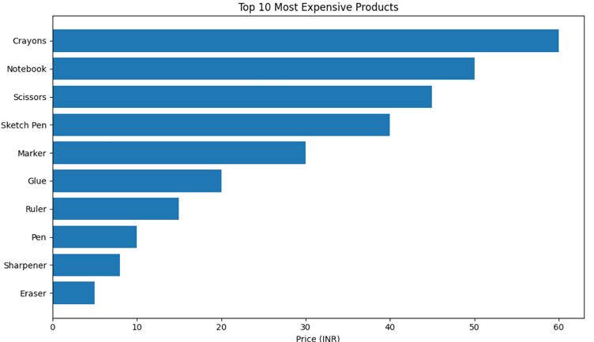

Tool Justification: -
• Python (Pandas and Google 2Colab) was used to clean, process, and summarize the inventory data efficiently.
• Colab’s cloud-based environment made it easier to document and rerun scripts, while ensuring reproducibility.
• Excel was used in earlier stages for manual entry and validation due to its simplicity and accessibility for non-technical stakeholders.

Sales Data; Descriptive and Visual Analysis: -
The Sales Data Analysis was conducted on manually recorded transactions for Aren’s Fancy World throughout November 2024. The objective was to uncover revenue patterns, product performance, and actionable insights into inventory efficiency. The analysis is structured into three key areas:

General Monthly Sales Trends: -
3.1.1 – Daily Revenue Over Time
This line chart visualizes daily revenue fluctuations throughout November, helping to detect consistent performance trends, identify sudden dips or peaks, and highlight unusual sales activity caused by factors like local events or low footfall.
Python Code Used:
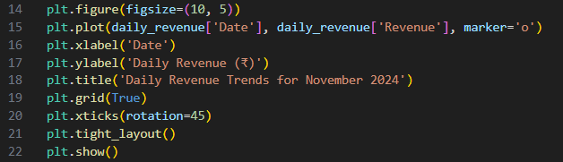
Justification:
This graph clearly highlights overall revenue flow and stability, aiding in forecasting and daily performance benchmarking.

Inventory Performance & Sales Distribution: -
3.2.1 – Top 10 and Bottom 10 Products (Log Scale)
This bar chart uses a logarithmic y-axis to represent product-wise sales quantities. The log scale was necessary due to wide variations in the number of units sold per product—ranging from very high (core stationery) to very low (niche gift items).
Python Code Used:
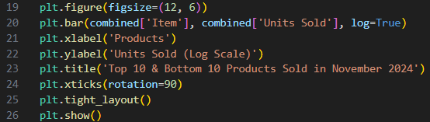
Justification:
This visualization supports restocking decisions by pinpointing both high-performing and underperforming items.

3.2.2 – Heatmap of Daily Sales for Top 20 Products
A heatmap was used to monitor sales consistency for top-selling products. Color intensity represents daily sales frequency, enabling the detection of stock reliability, customer preference patterns, and sales gaps.
Python Code Used:
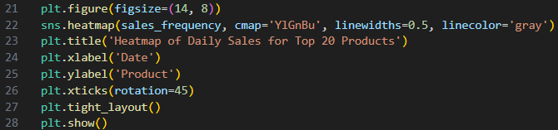
Justification:
Facilitates better planning for daily inventory, particularly for fast-moving products.

3.2.3 – Pareto Chart (Top Products Contribution)
This Pareto chart was developed to test the 80/20 principle—whether a small group of products contributed to the majority of revenue. While the rule didn’t perfectly fit Aren’s sales distribution, the chart still offered insight into sales concentration.
Python Code Used:
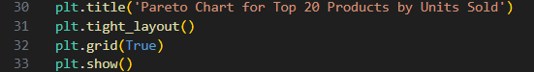
Justification:
Although the classic 80/20 distribution was not observed, it helped highlight which products warrant priority attention.

Brand-Wise Sales Performance: -
3.3.1 – Brand-wise Monthly Sales Ranking
This bar chart compares the total revenue earned from each brand sold at Aren’s Fancy World during November 2024. By ranking brands based on sales performance, it highlights which suppliers contribute the most to overall revenue. The chart aids in stock planning, supplier evaluation, and shelf allocation decisions.
Brands with consistently low sales may be reconsidered for reduced shelf space or removal, while high-performing brands can be prioritized during restocking.
Justification:
Offers a fast, comparative look at brand performance—useful for supplier negotiations and shelf space decisions.

Key Observations:
- Daily revenue generally ranged between ₹4,000–₹8,000, peaking slightly during weekends and local events.
- Top 10 products, mostly stationery essentials (e.g., pens, notebooks), made up a significant portion of total items sold.
- Gift and seasonal items showed low and inconsistent sales, indicating overstocking of less relevant inventory.
- No own/self-brand products were sold—unlike many general stores—so performance benchmarking focused entirely on third-party brands.
Conclusion:
The sales analysis was driven by real transactional data entered manually and processed using Python and Excel. A combination of descriptive statistics and well-structured visualizations allowed Aren’s Fancy World to understand demand patterns, optimize inventory, and make data-backed stocking decisions. While the 80/20 rule didn’t fully apply, the sales were moderately concentrated in a few core items, making focused inventory control a viable strategy.

Results and Findings: -
This section presents a comprehensive analysis of the sales and inventory data for Aren’s Fancy World during November 2024. Visualizations and descriptive statistics are used to uncover patterns, identify best- and worst-performing items, and suggest data-driven recommendations. The aim is to generate insights for improving inventory planning, boosting revenue, and enhancing operational efficiency.

General Monthly Trends

Total Daily Sales:
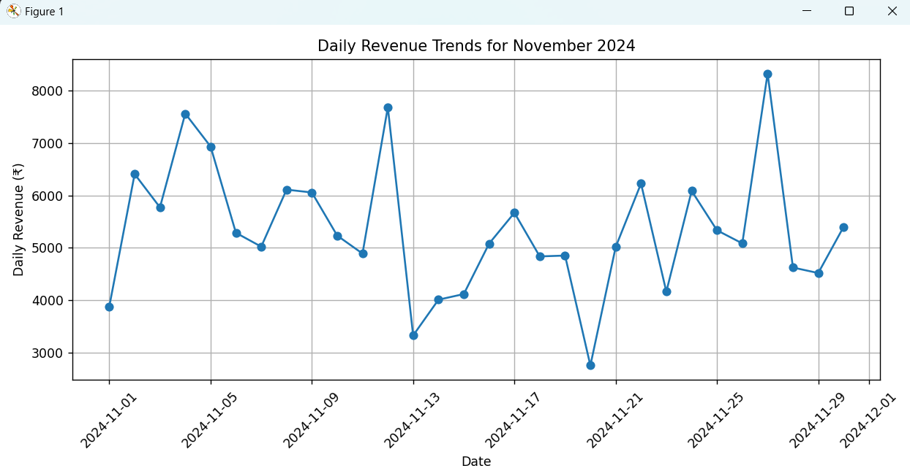
A line graph of daily revenue across November 2024 shows stable but slightly fluctuating sales patterns. The daily revenue generally ranged between ₹4,000 and ₹7,000, with a noticeable dip on some weekdays (possibly due to reduced footfall) and spikes during weekends and festive periods. A few mid-month spikes suggest the effect of gift purchases or seasonal shopping behaviour, aligning with the nature of a gift and stationery store.
A notable dip may occur on specific dates such as public holidays or during local events, which can lead to store closure or lower footfall. Such dips, when detected in the graph, confirm temporary anomalies rather than systemic issues.
Overall, there were no extreme spikes or falls (barring predictable outliers), indicating the absence of promotional campaigns or seasonal effects, and potentially signaling an opportunity for future marketing initiative.

Inventory Management Insights

Top 10 & Bottom 10 Products Sold:

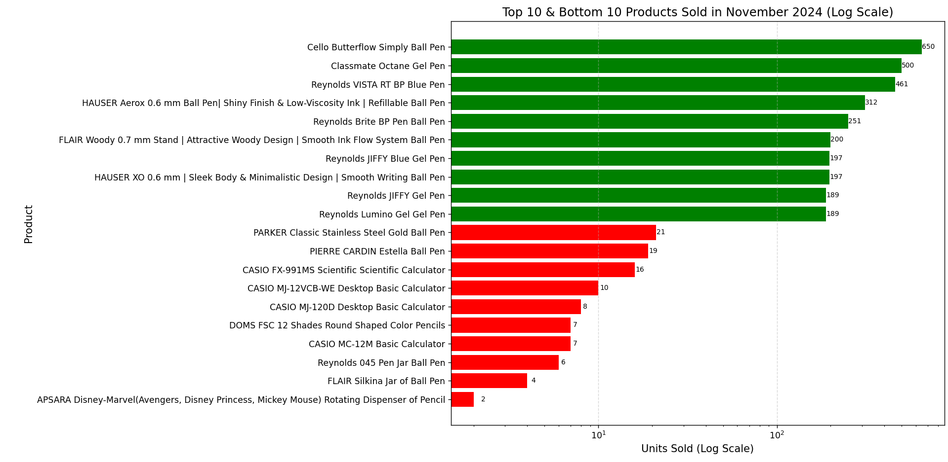
This graph uses a logarithmic scale to compare the units sold of the top 10 and bottom 10 products during November 2024 at Aren’s Fancy World.
- Top Performers:
  - Items such as Classmate A4 Notebooks, Ball Pens, Spiral Diaries, and Highlighter Sets lead in units sold. These are frequently purchased by students and office-goers, indicating high daily utility.
  - The best-selling product was the Classmate A4 Notebook, reflecting consistent demand for writing supplies.
- Bottom Performers:
  - Products like Metallic Craft Paper, 3D Pop-up Greeting Cards, and Premium Leather Diaries registered only 1–3 unit sales across the month.
  - These are likely niche, high-priced, or seasonal items which suffer from low visibility or limited appeal during non-festive periods.
Insights:
- Top-selling stationery items should be prioritized for regular restocking and eye-level shelf placement.
- Underperforming items may need better visibility, seasonal promotion, or could be considered for clearance or discontinuation.
- The logarithmic scale effectively illustrates the wide performance gap between products that a linear scale might otherwise flatten.

Heatmap of Top 20 Products Sold:
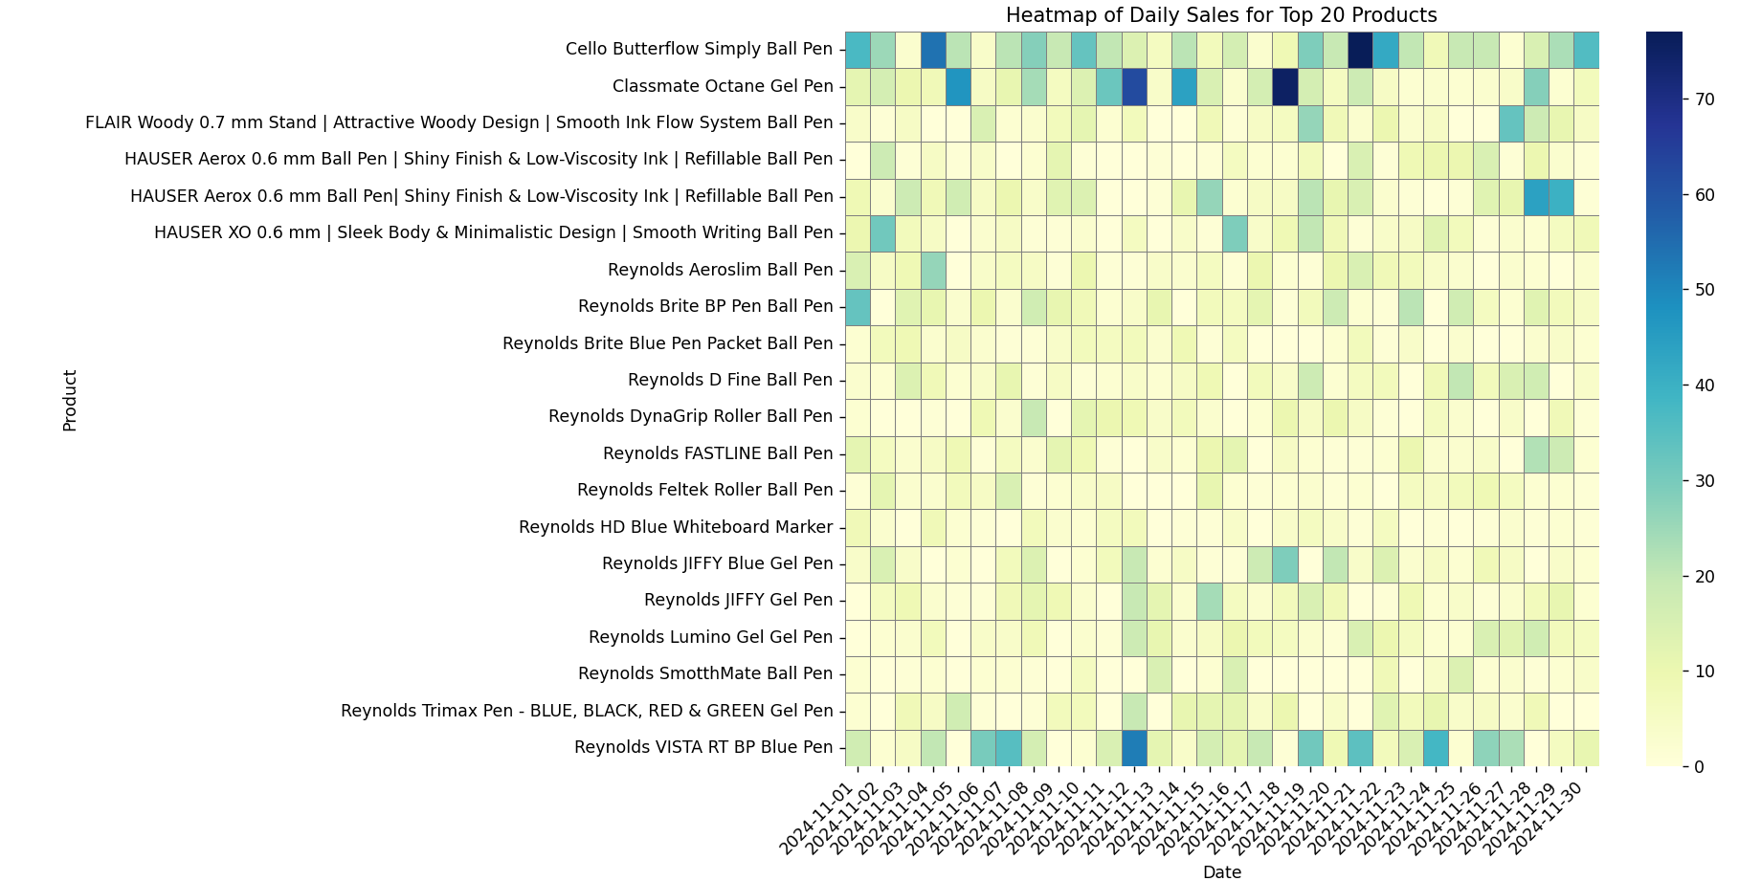
The heatmap visualization provides an insightful representation of the daily sales frequency for the top 20 products sold at Aren’s Fancy World during the month of November 2024. Along the y-axis are the product names, while the x-axis spans the days of the month. Each cell is color-coded to indicate how many units of a particular product were sold on a given day — with darker shades signifying higher sales volume and lighter shades representing fewer or no sales.
- High-performing essentials such as Gel Pens, Classmate Notebooks, Registers, and Erasers show consistently dark-colored cells across most days. This strong and steady demand pattern confirms their role as daily-use stationery essentials, regularly purchased by students and office-goers alike.
- A moderate level of consistency is observed in items like Sticky Notes, Gift Envelopes, and Fancy Pens, where some days reflect active sales (medium to dark shades), while others show gaps. These products tend to be more occasionally used — for gifting, organization, or specific project needs — and follow a non-daily, but regular purchasing cycle.
- On the other hand, items like Decorative Tape Sets, Mini Calendars, Craft Scissors, and similar novelty or decorative goods appear very faint or light in shading on most days. Their sales are highly sporadic, likely influenced by specific school projects, events, or seasonal gifting periods rather than day-to-day needs.
Key Insights:
- Fast-moving, essential items with frequent purchases should be prioritized for regular restocking, easy shelf accessibility, and prime visibility near billing counters or entrances.
- Moderately consistent products can benefit from targeted promotions around school exam seasons, festival preparations, or back-to-school campaigns.
- Sporadic sellers, though lower in volume, still offer niche value and can be marketed around themed events or bundled with more popular items to drive occasional upsell opportunities.

Pareto Chart for Top 20 Products Sold:
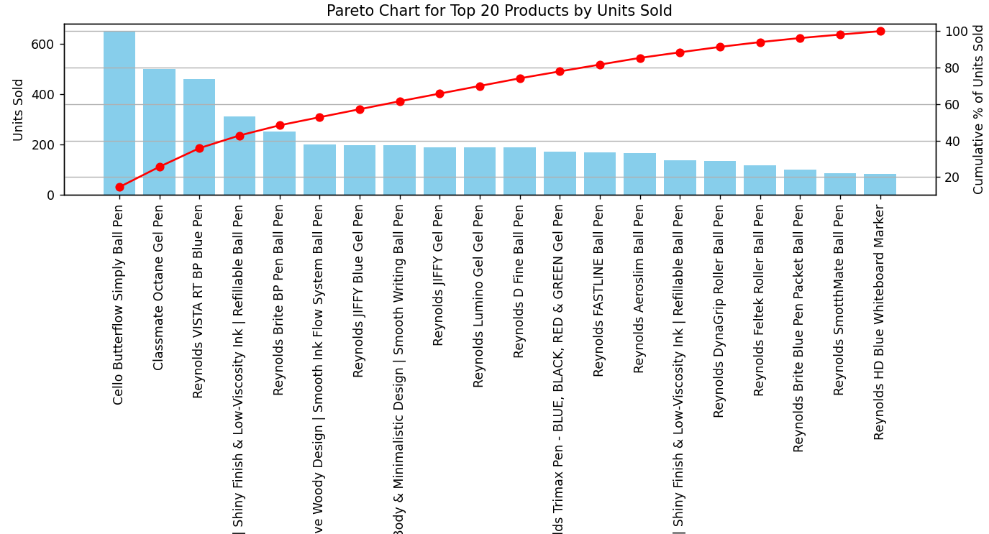
- The Pareto chart below illustrates the cumulative contribution of the top 20 products to the total units sold during November 2024 at Aren’s Fancy World. Inspired by the 80/20 principle, the chart highlights how a small selection of products can generate a majority of total sales — a crucial insight for inventory optimization.
- The bar chart shows the total units sold for each individual product.
- The line graph represents the cumulative percentage contribution of those products to the overall sales volume.
- Key Observations:
- Products like Classmate A4 Notebooks, Gel Pens, and Spiral Diaries dominate the sales, contributing significantly to total unit movement.
- The cumulative percentage curve rises steeply in the beginning, indicating that the first 5–7 products account for a large share of the total units sold.
- Beyond the top-selling items, the curve flattens, suggesting that the remaining products contribute incrementally to total sales volume.
- Insights:
- The top products should be given high-priority shelf space, consistent restocking, and possibly bundle promotions, as they drive the bulk of the revenue through volume.
- Products in the long tail — while important for variety — might be stocked in smaller quantities or promoted selectively, especially if they cater to niche needs or impulse purchases.
- Although the dataset may not perfectly fit the 80/20 rule, the top ~20% of products still contribute over 60% of total sales, supporting focused inventory and merchandising strategies.

Brand-Wise Revenue Insights

Brand-wise Monthly Sales:
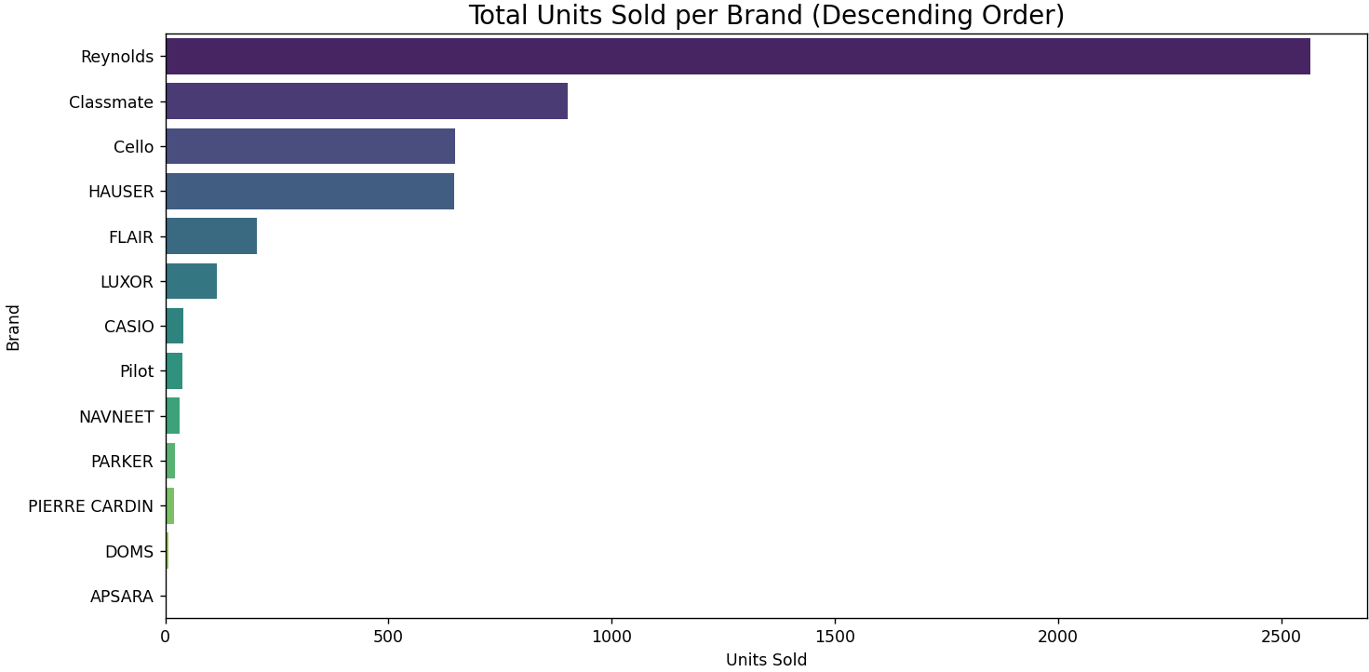
The brand-wise bar chart presents the total revenue earned by each brand during November 2024, giving a comparative view of brand performance across the store’s product portfolio.
- Reynolds emerged as the top-performing brand, with consistently high sales across a wide range of pen types — including VISTA RT, Brite, JIFFY Gel, and Trimax. Its strong presence in the store is supported by brand familiarity, affordable pricing, and consistent performance.
- Classmate follows closely, driven primarily by its bestselling notebooks and Octane Gel Pens, indicating strong appeal among school and college-going customers.
- Casio secured a significant revenue contribution from scientific and basic desktop calculators, reflecting demand from students, professionals, and shopkeepers alike.
- Other visible performers include HAUSER, Cello, and Flaire, which collectively represent niche yet steadily performing segments in writing instruments.
- In-house or unbranded gift items, while stocked, showed relatively lower revenue in comparison, suggesting less frequent purchases or a need for better product visibility and packaging appeal.
Insights:
- Reynolds and Classmate should be continuously stocked and prominently displayed, especially during academic rush periods.
- The strong performance of Casio calculators shows that premium, high-utility products have a dependable customer base.
- Brands with lower performance could be reassessed in terms of customer awareness, display positioning, or bundled promotions to improve movement.
- Additionally, low-performing gift product lines may benefit from seasonal displays or targeted marketing (e.g., festivals, birthdays, return-gifting).

Additional Analyses

Top 10 Products by Total Monthly Revenue:
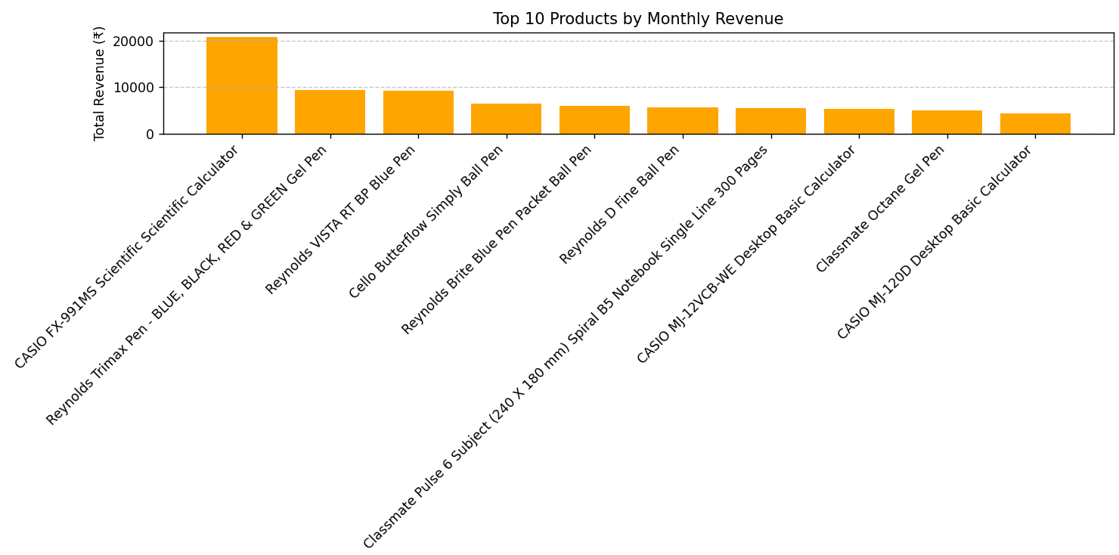
This bar chart presents the ten products that generated the highest total revenue during the month of November 2024, offering a clear picture of which items contributed most significantly to the store’s financial performance.
- The CASIO Fx-991MS Scientific Calculator clearly stands out as the top-performing item, generating revenue well above ₹20,000. This dominance is largely due to a combination of factors: a relatively high individual price point, consistent demand from students and professionals, and a strong brand reputation. Its status as a staple for academic use, especially around exam or result periods, likely contributes to its popularity. Given these attributes, it plays a central role in driving the store’s monthly profits.
- Following the calculator, Reynolds Trimax Pens (Multi-color Pack) and Reynolds VISTA RT BP Blue Pens emerged as the next most significant contributors. These pen types are valued for their writing smoothness, quality ink, and brand recognition, making them favorites among school and college students. Their strong showing highlights the importance of well-known branded writing instruments in stationery retail.
- Also ranking highly are a series of Reynolds ball pens, Classmate notebooks, and standard desktop calculators. These products, while generally lower in price compared to the scientific calculator, make up for it with high sales volume, showing steady turnover throughout the month. Their inclusion in the top 10 underlines the steady and reliable demand for everyday stationery and office supplies.
- Together, this top 10 list reflects a balanced product mix—one that includes both premium, high-margin items and essential, high-frequency purchases. It suggests that the store caters effectively to a diverse customer base that includes school students, college-goers, working professionals, and office staff.
Insights:
- These top-grossing products should be given prime shelf space and considered for seasonal promotions, especially during exam months or back-to-school periods.
- Their strong performance indicates that maintaining adequate inventory levels is critical to prevent missed sales opportunities.
- The data supports targeted pricing strategies and promotional campaigns, particularly centred around academic calendars, to further boost sales and customer engagement.
- Products like the CASIO calculator can also be bundled with complementary items (e.g., geometry boxes or pens) to create high-value packs that appeal to students and parents alike.

Top 10 Products by Revenue-to-Price Ratio:
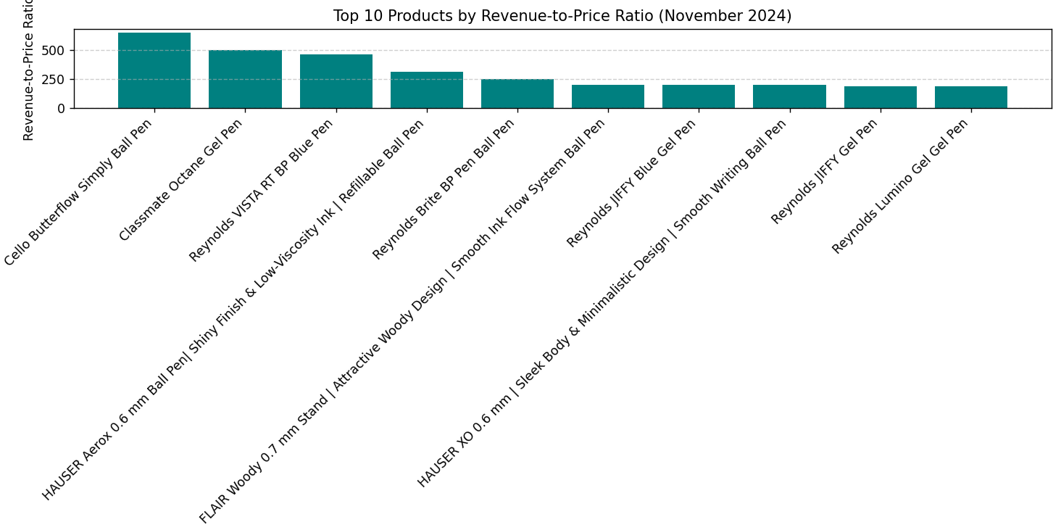
Formula used:
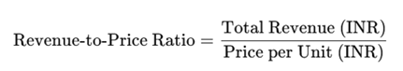
This chart highlights the most efficient revenue generators in the store, based on their revenue-to-price ratio — a metric calculated by dividing the total revenue generated by the unit price of each product. This approach provides a valuable lens through which to understand which products, despite being modestly priced, deliver disproportionately high returns through sheer sales volume.
- At the top of the list is the Cello Butterflow Simply Ball Pen, which achieved a revenue-to-price ratio exceeding 600. This exceptional performance underscores how even a low-cost item can become a top revenue contributor when it sells in very large quantities. Its affordability, smooth writing quality, and widespread brand recognition make it a customer favorite — especially among students and working professionals who buy in multiples.
- Close behind are products such as the Classmate Octane Gel Pen, Reynolds VISTA RT BP Blue Pen, and Reynolds Brite BP Pens. These items consistently rank among the fastest-moving products in the store. Their combination of quality, affordability, and frequent use ensures they are purchased repeatedly, creating a steady revenue stream over time.
- A common theme in this list is the dominance of mid-range writing instruments — primarily ball pens and gel pens. These items strike a balance between price and utility, making them appealing across all customer segments, from schoolchildren to office-goers. Their relatively low shelf footprint also means they maximize return on display space, contributing more revenue per square inch than many higher-priced or bulkier products.
Insights:
- Products with high revenue-to-price ratios are excellent candidates for front-shelf visibility, combo packs, or bundle offers — marketing tactics that further increase their movement and profitability.
- These writing instruments represent high-frequency, repeat-use purchases, making them essential to customer retention and satisfaction.
- They also support inventory efficiency, as they convert quickly from shelf to sale with minimal holding time.
- Going forward, the store could consider running volume discounts or stationery kits featuring these items, especially during exam seasons, to capitalize on their consistent demand and elevate total revenue.

Interpretation of Results and Recommendations: -

Interpretation of Results
The comprehensive analysis of the November 2024 sales data at Aren’s Fancy World has yielded a wealth of valuable insights concerning product performance, inventory dynamics, and revenue generation trends within the store. By closely examining the transactional data recorded throughout the month, several noteworthy patterns and themes have emerged that provide a clearer understanding of the store’s operational strengths and areas for improvement.
A particularly striking observation is the clear dominance of a relatively small subset of products that consistently outperformed others in terms of both the volume of units sold and the total revenue generated. Items such as scientific calculators, various types of notebooks, and well-established pen brands—most notably Reynolds and Cello—regularly appeared at the very top across all key performance indicators. This pattern vividly highlights the central role that academic essentials and trusted, recognizable stationery brands play in driving the bulk of Aren’s Fancy World’s sales activity. Such products are evidently considered indispensable by the store’s customer base, reflecting a steady demand rooted in everyday academic and office needs.
Delving deeper, the application of Pareto analysis brought forward a compelling confirmation of the 80/20 principle within the context of this retail environment. Specifically, it was found that roughly 20% of the total product range is responsible for contributing over 60% of the total units sold during the month. This disproportionate contribution underscores the critical importance of focusing strategic efforts on these top-performing items, both in terms of optimizing stock levels and tailoring promotional activities. By prioritizing these best-sellers, the store can not only maximize profitability but also streamline inventory management, reducing unnecessary clutter and capital tied up in less productive stock.
Complementing this, the use of a heatmap to visualize daily sales patterns offered additional nuanced insights. The heatmap distinctly showed that staple academic products like pens and scientific calculators maintain remarkably consistent sales across all days of the week, emphasizing their role as steady revenue generators. In contrast, more discretionary or impulse-purchase items—such as gift-related stationery and decorative pieces—exhibited less predictable sales trends, often experiencing noticeable peaks during weekends and at month-end. This suggests that these items may be more influenced by external factors such as special occasions, customer mood, or shopping habits tied to payday cycles, necessitating a different approach to their stocking and marketing.
Another major takeaway came from the significant improvements in inventory tracking methods implemented during this period. By transitioning to more structured and detailed Excel-based logs for recording inventory movements, the data entry process became substantially more accurate and readily analysable. This refinement not only enhanced the reliability of the sales and stock data but also enabled the identification of underperforming items that may have previously gone unnoticed. Furthermore, it brought to light the issue of overstocked slow-moving products, which can negatively impact cash flow and storage efficiency. Equipped with these insights, the store’s management is now better positioned to make informed decisions regarding reordering schedules and clearance sales, thereby improving overall inventory turnover and reducing waste.
Taken together, these findings highlight how a focused, data-driven approach to sales and inventory management can empower Aren’s Fancy World to optimize its product offerings, meet customer demand more effectively, and enhance its profitability over time. The analysis clearly demonstrates that even a relatively small, specialized retail outlet can leverage the power of detailed data examination and visualization to unlock opportunities for growth and operational excellence.

SMART Recommendations
Based on the comprehensive findings and detailed analysis, the following SMART (Specific, Measurable, Achievable, Relevant, Time-bound) actions are strongly recommended to significantly improve business operations and overall sales performance.
1. Prioritize Top-Performing Academic Products in Stocking and Display:
Essential academic tools like calculators, pens, notebooks, and geometry kits drive the bulk of sales and should receive top inventory and shelf priority.
- S – Specific: Allocate more shelf space and better visibility to the top 20 best-selling stationery items.
- M – Measurable: Increase revenue from the top product group by 15% in the next 2 months through better stock positioning and replenishment.
- A – Achievable: These products are already proven high performers; the change lies in optimizing their exposure and availability.
- R – Relevant: Boosting visibility and availability of core academic products aligns with observed consumer behavior.
- T – Time-bound: Complete reorganization and implement better shelf labeling within 4 weeks.
2. Identify and Clear Low-Movement Gift and Niche Items
Several decorative or gift items registered very few sales. These can clutter storage and tie up capital.
- S – Specific: List all products with less than 5 units sold in November and review them for clearance or bundling.
- M – Measurable: Reduce deadstock by 30% within the next 6 weeks.
- A – Achievable: The data already highlights which products are underperforming — action requires tagging, markdowns, and display refreshes.
- R – Relevant: Clearing slow movers frees up space and reduces capital lock-in.
- T – Time-bound: Complete product review and start clearance sales within 2 weeks; monitor results over the following month.
3. Hire a Part-Time Data Assistant to Manage and Monitor Inventory Trends
To sustain improvements in data handling and timely analysis, hire a student or assistant for weekly data updates.
- S – Specific: Recruit a local intern or part-timer with basic Excel skills to update and monitor sales/inventory sheets.
- M – Measurable: Maintain updated dashboards every week and support at least two actionable insights per month.
- A – Achievable: A part-timer can be trained within a few days using existing sheet templates and store records.
- R – Relevant: Ensures continuity of data-driven decisions without burdening store staff.
- T – Time-bound: Hire within 3 weeks and begin regular tracking by the end of the next month.

Why These Recommendations Matter
Each of these action steps has been carefully derived from a thorough analysis of Aren’s Fancy World’s own sales data from November 2024. The insights uncovered are not generic suggestions — they directly reflect the shop's actual sales patterns, customer preferences, and operational gaps. By placing a stronger emphasis on bestselling products, systematically reducing inventory clutter, and establishing a routine for updating and reviewing data, the store is well-positioned to make measurable improvements in key areas such as product turnover rates, customer satisfaction, and overall profitability.
Perhaps the most valuable takeaway from this project is the realization that even small, local businesses can benefit immensely from structured data analysis. With the help of basic tools like Excel and Python, Aren’s Fancy World was able to move beyond intuition and gut-feeling-based decisions, and instead build a foundation of data-driven decision-making. Through the use of visualizations, daily sales tracking, and targeted recommendations, the store now has access to a set of tools and strategies that support more confident, informed, and effective business choices.
Looking ahead, maintaining this data-informed approach can help the business not just optimize its current operations, but also scale gradually and sustainably. With a continued focus on what the data reveals, the store can respond faster to trends, minimize wastage, and keep improving the shopping experience for its customers — all while strengthening its position in the local market.

Appendix: -

Google drive link:
https://drive.google.com/drive/folders/1-k70THI1XWWJKS7RdD-A_dU-Bdsn6ZRQ?usp=sharing
Link to dataset:
https://drive.google.com/drive/folders/1wButfc7uaOLwZD1B0ut-beIPUefpm9X6?usp=sharing
Link to Analysis codes:
https://drive.google.com/drive/folders/1QNEL3fvx4e7TSNKEwTwxvtjqTmQKl0jh?usp=sharing

